**June 8th How rests are used to complete measures Due June 15th**

|  |
| --- |
| **Paste rest symbols from the internet:**  **1. into the measures if you can figure it out.**  **2. underneath the measures if you cannot.** |

**\*Rests (and notes) must be spaced in a bar so that they match the beats underneath.**

**\*Generally, no rests greater than one beat should be used.**

**THIS IS CORRECT 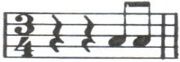 THIS IS NOT AS GOOD 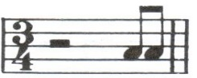 (YOU MUST SEE 3 BEATS)**

**Beat 1 2 3 1 2 3**

**Knowledge (25)**: Complete with **rests**: (pay attention to the time signature)

**\*A beat should be completed with the biggest rest value possible.**

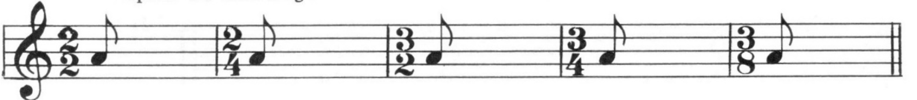

🡪

**Thinking (25)**: Complete with **rests**: (pay attention to the time signature)

\***Each beat must be completed before the next beat can begin**



🡪

**Application (25)**: Complete with **rests**: (pay attention to the time signature)

**\*Each part of a beat must be complete before the next part begins.**

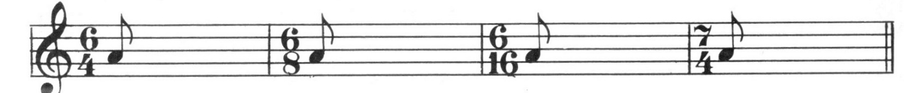

🡪

 

**(You must see beat 2 separated from beat 3)**

**Communication (25)**: Complete with **rests**: (pay attention to the time signature)



